**CNN Based Deep Learning Method for Detecting Breast Cancer**

Utkarsh1, Varun Kumar2, Yashit Kumar3, Kapil Sharma4

1,2,3,4Information Technology

1,2,3,4Delhi Technological University

1,2,3,4Delhi, India

[1utkkumar8@gmail](mailto:3sahgalamar5@gmail.com).com

[2varunkmr038@gmail](mailto:3sahgalamar5@gmail.com).com

[3yashitkumar8@gmail](mailto:3sahgalamar5@gmail.com).com

[4](mailto:4prashant.shambharkar@dtu.ac.in)kapil@ieee.org

**ABSTRACT**

Cancer remains one of the deadliest illnesses in the world, with almost 10 million deaths recorded in the last year alone. Breast cancer (BC) accounts for 22.6% of these fatalities, making it one of the worst cancer kinds. In India, breast cancer represents 14.7% of all cancer cases and is the main reason of cancer-related deaths. Despite numerous studies on early breast cancer detection, a significant percentage of cases remain undiagnosed, with only about 86% of cases being identified correctly. Early detection is crucial to facilitate prompt treatment initiation and reduce mortality rates. The risk of incorrect detection in cell biopsy pictures puts a person's life at danger. Easily adaptable new alternative methods for a variety of data sets, are inexpensive, dependable, and safer, and can provide an accurate forecast are urgently needed. Convolutional Neural Networks (CNNs) were proposed in this study for breast mass identification in order to reduce the costs associated with manual analysis since deep learning techniques are revolutionising the area of medical image analysis. The final authority on cancer diagnosis is with surgical pathologists. In the absence of a tissue diagnosis, the diagnosis of cancer cannot be reliably inferred, regardless of how high the index of clinical suspicion may be. With very few circumstances, definite cancer treatment shouldn't begin before a tissue diagnosis has been made. Most hospitals have policies supporting this practice spelt out in their bylaws, and hospital tissue committees and accrediting organisations keep a close eye on them. Understanding the issue at hand, to determine the likelihood of breast cancer, we propose a classification model using CNN.

Keywords- Histopathology images, Deep Learning, Breast Cancer Detection, Convolutional Neural Networks.

**INTRODUCTION**

Breast cancer, a prevalent malignancy that commonly affects females, is the second-most frequent reason for mortality in women. Breast cancer has become increasingly common worldwide over time, and each year, more instances are reported. It affects more women than other types of malignancies. If this illness is not identified in a timely manner, it might be fatal [1]. Based on how the cell appears under a microscope, different types of breast cancer are categorised. Invasive ductal carcinoma and ductal carcinoma in situ are the two main types of breast cancer, the latter of which takes time to manifest and often has no effect on patients' day-to-day activities. There are few incidences of the DCIS type (between 20% and 53%), but many instances of the IDC kind., which surrounds the whole breast tissue, is more harmful. This applies to about 80% of breast cancer patients [2].

Early detection increases the likelihood of effective treatment and survival, but its diagnosis takes time and usually necessitates consensus amongst pathologists. Systems for computer-aided diagnosis (CAD) can increase the precision of diagnoses. Lack of early diagnosis forces thousands of women to undergo risky, painful, and scar-causing operations. To address these and similar issues, several studies have been carried out using both conventional machine learning and deep learning-based methodologies. Therefore, having access to reliable screening techniques is crucial for identifying breast cancer's early warning signs. The most common imaging methods used to look for this syndrome are thermography, ultrasonography, and mammography. One of the most crucial techniques for detecting breast cancer early is mammography. Diagnostic sonography procedures like ultrasonography are widely used since mammography is useless for breasts with solid tissue. Given these concerns, thermography may be a more effective method than ultrasonography for identifying tiny malignant tumours, however radiography can prevent microscopic masses [3].

Medical imaging and deep learning (DL) techniques will aid in this process. Medical imaging has a substantial impact on clinical illness diagnosis, therapy evaluation, and the identification of anomalies in many biological organs, including the eye [4], lungs [4], brain [5], breast [6], and stomach [7]. Medical image research, which is recognized as a feasible method to get useful information from enormous volumes of data, tries to categorise the organ in question's location, dimensions, and characteristics. Medical imaging includes ultrasound, magnetic resonance imaging (MRI), histology, mammography, and thermography images, is the most reliable method for detecting breast cancer [8].

The challenging problems in deep learning (DL), a branch of artificial intelligence and machine learning structure of picture features, has the capacity to learn on its own. A range of recently developed models are used by DL approaches to boost feature extraction from data. Various medical disciplines have employed these variations. Deep learning (DL) employs multilayer neural networks (NNs) to build a hierarchical feature structure from the raw input images. Convolution NNs (CNNs) and stack auto encoders are examples of common deep learning (DL) techniques [9].

**LITERATURE REVIEW**

The efficacy of Ensemble Support Vector Machine (ESVM) in detecting breast cancer was investigated by Wang et al. [10]. Four pre-trained models, including multi-level InceptionV3, ResNet-50, DenseNet-121, and multi-level VGG-16, were employed in conjunction with ESVM, which yielded a maximum classification accuracy of 94.70%. The authors found that their proposed approach outperformed existing state-of-the-art methods. Additionally, to further boost the classification performance, they incorporated an integrated feature mining and voting approach by training their E-SVM classifier.

Li et al. [11] suggested a method for selecting extra Selective patches that combines a deep learning CNN (Convolutional Neural Network) with a clustering ML algorithm. The highest obtained 95% accuracy on the primary test set and 88.89% accuracy on the entire test set using the approach that was projected on four classes that are utilised for the categorization of BC (breast cancer) using photographs. The results are logically related to further state-of-the-art systems' results.

With the use of patients' medical pathology pictures, Sudharshan et al. [12] present a weakly machine learning supervised method and determine the applicability of MIL for a CAD system to identify breast cancer in patients. The BreakHis dataset, which includes histopathology scans from 82 patients, is used for the experiment. They were able to get better outcomes than predicted classification without labelled pictures thanks to multiple instance learning. Their suggested task has a 92% accuracy rate.The initial use of Multiple Instance Learning (MIL) was to predict drug action [13]. Later versions of it, such diversified density (DD), expectation-maximization of the DD function (EM-DD) [14], and MI-support vector machine (MI-SVM) [15], also became well-liked. Typically, MI-SVM combines the SVM architecture with MI inferencing. Another well-known technique that utilises an ensemble of several weak classifiers in the context of MI is MILBoost [16]. When using histological breast pictures, Roy et al. [17] suggested a PBC (Patch-based classifier) by applying DCNN for the automated diagnosis of cancer. One Patch in One Decision (OPOD) and All Patches in One Decision (APOD) are the two phases of their suggested approach. In their experimental investigation, they found that APOD classification accuracy was 92.5% and OPOD classification accuracy was 84.7%. They were 87% accurate for the ICIAR-2018 concealed dataset

In order to categorise breast tissue as benign or malignant, Gandomkar et al. [18] established a procedure. They then further classified these 2 groups into 4-4 each additional category. Tubular adenoma, Phyllodes tumour, and other benign tumour types. There are four types of malignant cancer: lobular, ductal, papillary, and mucinous. To determine if a patient has breast cancer or not, they employ ResNets, or a deep residual network. For the purpose of early cancer detection, Komura and Ishikawa [19] suggested a method to analyse histopathological pictures with the use of a computer-aided diagnostic system. Their suggested method performs admirably and offers 92.7% accuracy. To exclude the beneficial characteristics from the histopathology pictures, D. M. Vo et al. [20] suggested a DCNN combining the strengths of both weak and strong classifiers.The identification of cancer has then seen better results compared with conventional teaching methods. Instead of using a multinetwork, they extract features using a single network.

Table 1. Different classification models with their accuracy and methods

|  |  |  |  |  |
| --- | --- | --- | --- | --- |
| **Author** | **Dataset** | **Method** | **Accuracy** | **Remarks** |
| Wang et al. [10] | ICIAR 2018 dataset of medical histopathology pictures | DCNN | 94.70% | Tested Ensemble Support Vector Machine (ESVM) on DCNN using four pretrained models. |
| Li et al. [11] | MRI images | DCNN + Clustering ML | 88.89% | The method was applied to four categories that are used to classify breast cancer using photos. |
| Sudharshan et al. [12] | Histopathology scans from 82 patients | MIL | 92% | Introduced a weakly machine learning supervised approach and evaluated the applicability of MIL for a CAD system to identify breast cancer in patients. |
| Roy et al. [17] | Histological breast pictures | DCNN | 92.50% | One Patch in One Decision (OPOD) and All Patches in One Decision (APOD) were the two phases they suggested for their technique. |
| Gandomkar et al. [18] | Breast histopathology picture | ResNets + Deep residual network | 92.15% | Classified the 2 groups into 4-4 each additional category. Tubular adenoma, Phyllodes tumour, and other benign tumour types. |
| Komura and Ishikawa [19] | Histopathological pictures | CAD | 92.70% | Used to spot cancer in its earliest stages. |

**PROPOSED METHODOLOGY**

CNN is a well-organized architecture used in MIP. CNNs are a subset of DNNs, which are networks that can recognise and categorise certain elements of pictures and are frequently used for processing visual data. CNNs were developed to reduce processing requirements and operate similarly to multilayered perceptrons. This work presents a CNN architecture that can correctly identify the cancer from breast histopathology images. The fundamental CNN model is changed, and a significantly upgraded or improved version is shown that produces the greatest results for detecting breast cancer.

Image Preprocessing - Before they may be used for inference and model training, images must be preprocessed. It includes, but is not limited to, changes in size, color, and orientation. Pre-processing’s sole purpose is to improve the image's clarity so that we can better understand it. Preprocessing can be used to improve certain qualities that are important for the job at hand and remove undesirable abnormalities.

Layers of Convolution

Fully-connected (FC) layers, convolutional layers, and pooling layers are the three different categories of CNN layers. A CNN architecture is created by stacking these layers. In addition to these three layers, there seem to be two other key elements, the activation function or ReLU function and the dropout layer, which are detailed below.

Convolution Layer - Now, a MxM filter is used to convolve the input image in order to create a new output image. To assess the filter's impact on the input image (MxM), parts of the source image that fall within the filter's size range must be calculated to create the dot product between them, just drag the filter over the source image. The resulting "Convolution layer" reveals details such as an image's borders and bounds. Successive layers To discover more about the input image, obtain this feature map. A CNN's convolution layer will communicate the output to the subsequent layer when the convolution procedure on the input has been completed.

Batch Normalization Layer -Before sending information on to the following layer, the network uses batch normalization layers to normalize the activations of a particular input quantity.

Pooling Layer - A Convolutional Layer is usually put before this layer. The most noticeable map feature is chosen by Max Pooling.

Fully Connected Layer (FC) -The neurons, biases, and weights of the FC layer are utilised to create connections between layers. Before the output layer, these layers are frequently the final in a CNN architecture. The input picture from the top layers is shrunk during this process and transferred to the FC layer.

Activation Functions - In essence, this function plays an important part in the CNN paradigm. It is possible to detect and approximate a wide range of complicated and continuous relationships between network variables with this method.The activation functions SoftMax, ReLU, Sigmoid, and tanH are widely used activation functions. Each of these attributes has a particular purpose in the model.

Dropout Layer - The last layer type we'll discuss is dropout layers. Dropout is a regularisation method that puts more emphasis on training precision than test accuracy. In our training set, each mini-batch is processed by a network with dropout layers that sporadically deactivate inputs from the layer below.

Image Preprocessing - Before they may be used for inference and model training, images must be preprocessed. It includes, but is not limited to, changes in size, colour, and orientation. Pre-processing's sole purpose is to improve the image's clarity so that we can better understand it. Preprocessing can be used to improve certain qualities that are important for the job at hand and remove undesirable abnormalities.

**IMPLEMENTATION AND RESULTS**

A. Dataset Explanation

A 2D Deep CNN architecture is showcased in this study for identifying breast cancer. This study made use of the Breast Histopathology Images collection. This dataset includes 277,524 images in which breast cancer was present in 78,786 images and breast cancer was not present in the remaining 198,738 images. On Kaggle, this dataset is accessible to everyone. This dataset comprises of images in jpeg format. All images have same sizes 50 x 50. After dividing the dataset into testing and training data, normalization is applied on both categories. As explained in the previous sections, CNN is a well-defined strategy in medical image processing field. A far better variant of the fundamental CNN architecture is showcased in this study.

B. Proposed Model

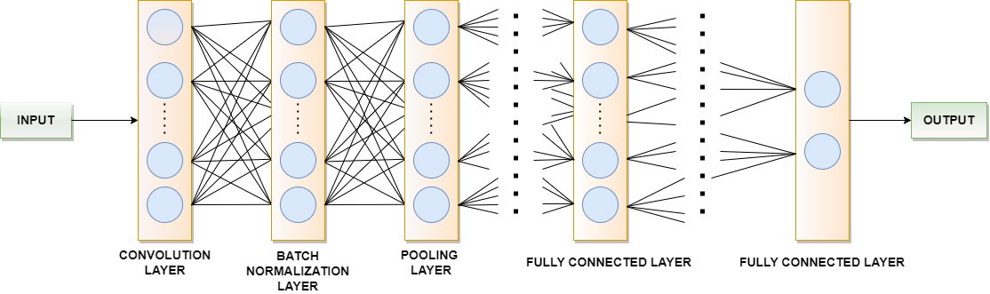

Fig. 1. Implementation details of showcased model for breast cancer detection

A twenty two layer CNN architecture has been proposed by us, which gave outstanding results in identifying breast cancer. The diagram represented in Fig. 1 gives a brief description regarding how our proposed model has been implemented. We have first created a convolutional layer comprising of 32 convolutional filters, each having dimension 3*3, This first convolutional acts as input layer for the showcased model. The ReLU function is selected as activation function for this layer. If the input value is positive, ReLU function will output value same as input value, else it outputs zero. Batch Normalization layer is applied after this convolutional layer. Batch Normalization is an approach through which neural networks are created quickly and additional stability is added by normalization of layers’ inputs. Another convolutional layer comprising 32 filters, each having dimension 3*3 is added. Next, a max pooling layer is added, in which a 2D filter is slid over every channel of feature map. This helps in encapsulating fundamental characteristics of the area covered by filter. Also, the pooling layer diminishes the output shape, which in turn narrows down the number of parameters in the model defined. Since pooling layer encapsulates features, the additional computations will be performed on those encapsulated features instead of accurately determined features presented by the convolutional layer. The most critical characteristics of the input feature map will be the output of max pooling layer. The max pooling layer is followed by another batch normalization layer which is further followed by a dropout layer with dropout ratio 0.3. Next, a convolutional layer that consists of 64 convolutional filters, each with a size of 3*3, using ReLU as the activation function. The second convolutional layer is coupled to a further batch normalization layer which is further followed by a max pooling layer and dropout layer similar to the previous ones. Another convolutional layer consisting of 128 convolutional filters each having dimensions 3*3 with activation function selected as ReLU is added next to the max pooling layer. A flatten layer is then added to flatten the 3D feature map obtained after performing convolutional, pooling and batch normalization functions on our input image, into a 1D dense layer. Five dense layers have been added in the showcased deep CNN architecture. The initial dense layer encompasses 128 neurons with activation function set to ReLU function. 64 neurons make up the second dense layer. The third dense layer encompasses 64 neurons with activation function again set to ReLU function. A dropout layer is attached after the third dense layer with dropout ratio 0.3. This is done to reduce overfitting in our proposed CNN architecture. The fourth dense layer encompasses 24 neurons with activation function again set to ReLU function. The last dense layer contains 2 neurons which give the final output as to whether the image contains breast cancer or not. The activation function in this dense layer is set to the Softmax function. Then the model is trained for 40 epochs with the Adam optimizer and loss as binary cross entropy as we are classifying binary inputs and learning rate of 0.0001.

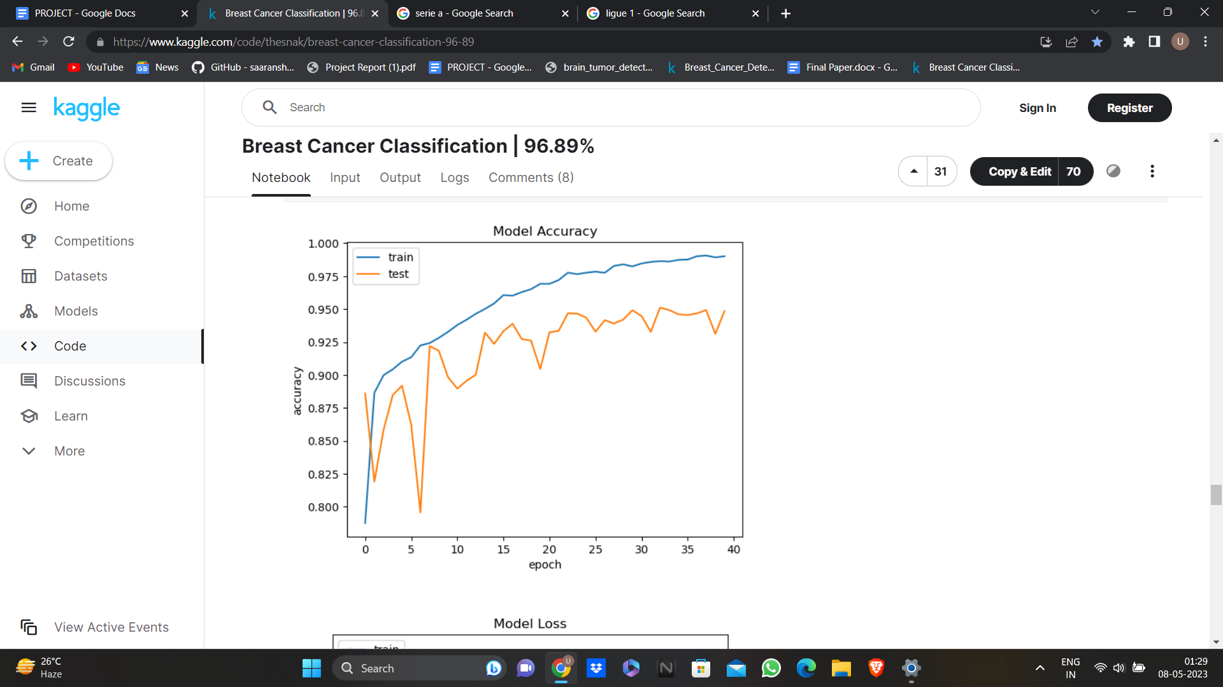

Fig. 2. Accuracy in training and validation

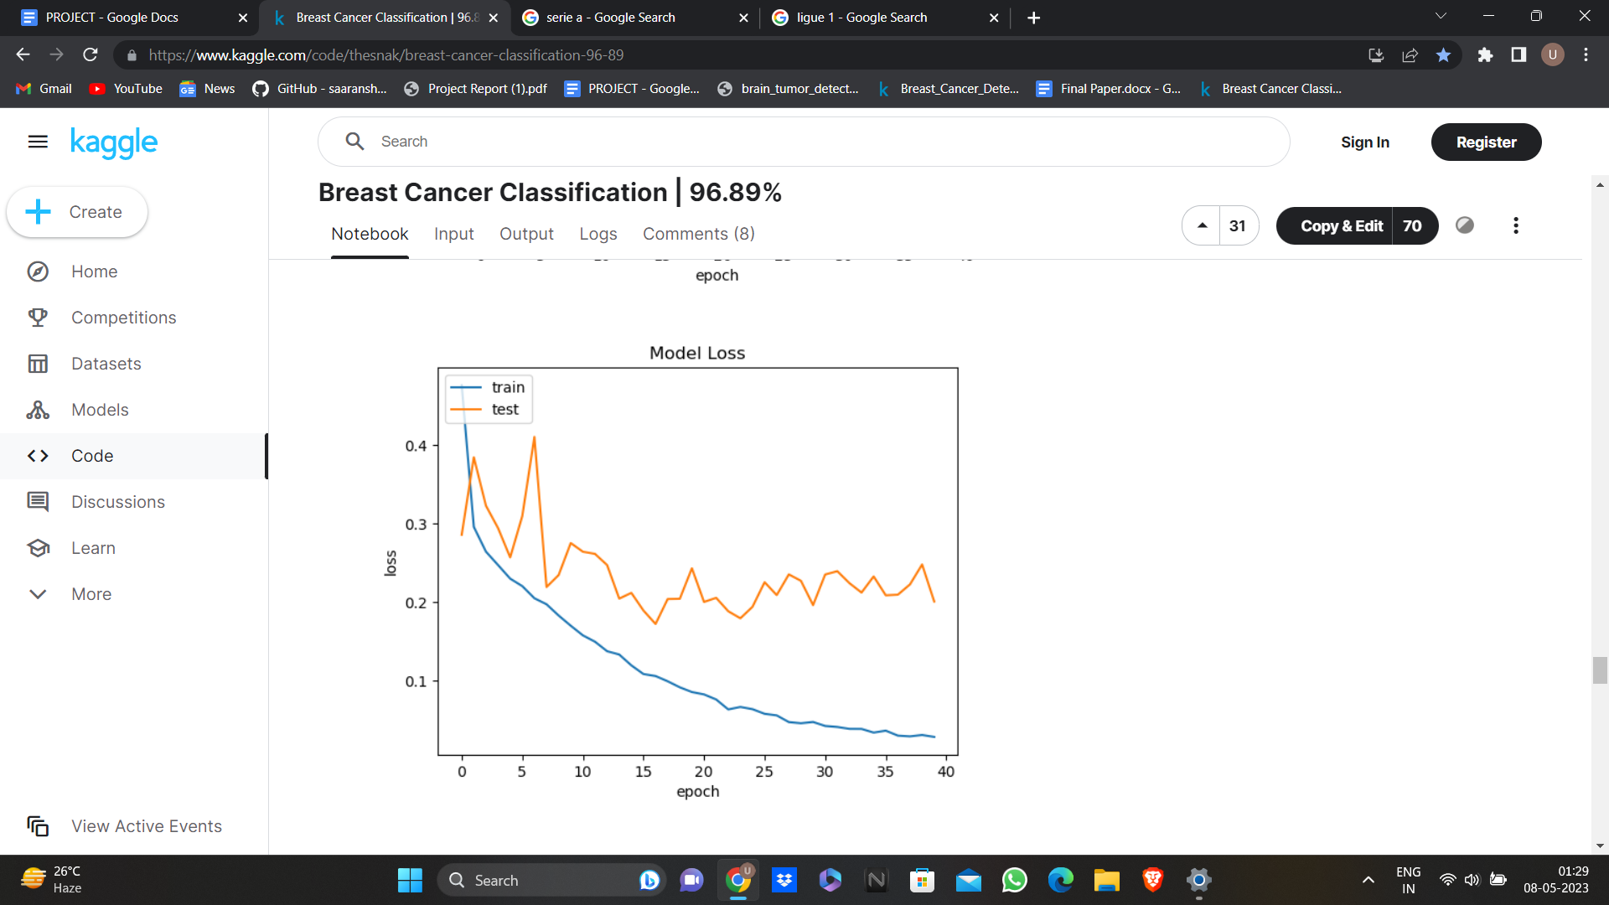

Fig. 3. Loss in training and validation

The graph represented in Fig. 2. displays the discrepancy in accuracy of validation and training data. The number of epochs is represented on x-axis while accuracy is measured on y-axis. According to the graph, the training accuracy attained is greater than the validation accuracy. The graph represented in Fig. 3. displays the discrepancy in loss of validation and training data. The number of epochs is represented on x-axis while loss is measured on y-axis. The training loss attained is lower than the validation loss as seen from the graph.

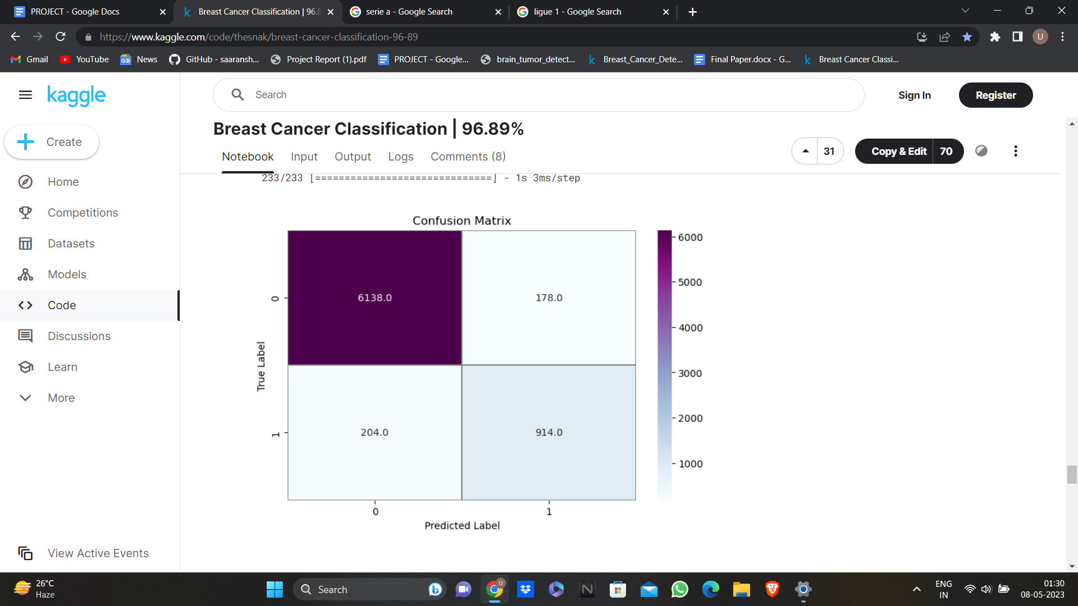

Fig. 4. Confusion matrix of showcased architecture of testing data

A confusion matrix represented in Fig. 4. is created for analysing the showcased model on the chosen dataset. The showcased model attained a 81.76% recall, 94.86% accuracy, 82.71% F1 score, 83.70% precision.

Table 2. Comparison of performance among previous proposed models

|  |  |  |  |  |
| --- | --- | --- | --- | --- |
| **Author** | **Year** | **Method** | **Accuracy** | **Remarks** |
| Romero et al. [22] | 2019 | CNN (Multi-level Batch normalization) | 89% | Composed of blocks derived from Inception that integrates batch normalization after each convolution step. |
| Proposed method | 2023 | CNN | 94.86% | A 22 -layer CNN model with Adam optimizer and binary cross entropy as loss function is proposed. |

**CONCLUSION**

The objective is to increase the pathologist's productivity by swiftly determining whether a sample of tissue is malignant or not by running it through the CNN model. The procedure can be made much more efficient by using the model because it can handle thousands of photos' worth of data in a matter of minutes, as opposed to days if it were done manually. In order to discriminate between each class and generate the best results, a CNN must extract characteristics from each image. The aforementioned report demonstrates that the model produces commendable outcomes. The CNN model architecture is being developed to automatically identify breast cancers. We evaluate our suggested model using a dataset of 277,524 patches.With a 40-epoch strategy, Our CNN model includes 22 layers. To reach our final result, we used 30% of the images as testing data and 70% of the images as training data. The proposed model has a 94.86% overall accuracy in detecting cancers from photos. The proposed approach may be seen as a computer-aided automated detection tool for precisely identifying breast abnormalities in histopathology data.The model might be enhanced. The model's output for current recall is adequate. The recall may be further enhanced for application in the actual world. Pathologists can find cancer on tissue more quickly thanks to this model. Examining tissue slides by hand would not be necessary.

**REFERENCES**

[1] Hamidinekoo A, Denton E, Rampun A, Honnor K, Zwiggelaar R (2018) Deep learning in mammography and breast histology, an overview and future trends. Med Image Anal 47:45–67.

[2] M. Masud, A. E. Eldin Rashed, and M. S. Hossain, “Con-volutional neural network-based models for diagnosis of breast cancer,” Neural Computing and Applications, vol. 5, 2020.

[3] G. Muhammad, M. S. Hossain, and N. Kumar, “EEG-based pathology detection for home health monitoring,” IEEE Journal on Selected Areas in Communications, vol. 39, no. 2, pp. 603–610, 2021.

[4] Shahzad A, Usman AM, Muhammad S, Anam T, Khan Shoab A (2018) Decision support system for detection of hypertensive retinopathy using arteriovenous ratio. Artif Intell Med 90:15–24.

[5] Rajinikanth V, Satapathy SC, Fernandes SL, Nachiappan S (2017) Entropy based segmentation of tumor from brain mr images-a study with teaching learning based optimization. Pattern Recogn Lett 94:87–95.

[6] Fonseca P, Mendoza J, Wainer J, Ferrer J, Pinto J, Guerrero J, Castaneda B (2015) Automatic breast density classification using a convolutional neural network architecture search procedure. In: Medical imaging 2015: computer-aided diagnosis. International Society for Optics and Photonics, vol 9414, p 941428.

[7] Khan MA, Sharif M, Akram T, Yasmin M, Nayak RS (2019) Stomach deformities recognition using rank-based deep features selection. J Med Syst 43(12):329.

[8] Houssein EH, Emam MM, Ali AA, Suganthan PN (2020) Deep and machine learning techniques for medical imaging-based breast cancer: A comprehensive review. Expert Syst Appl 167:114161.

[9] Yap MH, Pons G, Martí J, Ganau S, Sentís M, Zwiggelaar R, Davison AK, Robert Martí (2017) Automated breast ultrasound lesions detection using convolutional neural networks. IEEE J Biomed Health Inform 22(4):1218–1226.

[10] Y. Wang, B. Lei, A. Elazab, E.-L. Tan, W. Wang, F. Huang, X. Gong and T. Wang, "Breast Cancer Image Classification via Multi-Network Features and DualNetwork Orthogonal Low-Rank Learning," IEEE Access, vol. 8, p. 27779–27792, 2020.

[11] Y. Li, J. Wu and Q. Wu, "Classification of breast cancer histology images using multi-size and discriminative patches based on deep learning," IEEE Access, vol. 7, p. 21400–21408, 2019.

[12] P. J. Sudharshan, C. Petitjean, F. Spanhol, L. E. Oliveira, L. Heutte and P. Honeine, "Multiple instance learning for histopathological breast cancer image classification," Expert Systems with Applications, vol. 117, p. 103–111, 2019.

[13] O. Maron and T. Lozano-Pérez, ‘‘A framework for multiple-instance learning,’’ in Proc. Adv. Neural Inf. Process. Syst., 1998, pp. 570–576.

[14] Q. Zhang and S. A. Goldman, ‘‘EM-DD: An improved multiple-instance learning technique,’’ in Proc. Adv. Neural Inf. Process. Syst., 2002, pp. 1073–1080.

[15]  S. Andrews, I. Tsochantaridis, and T. Hofmann, ‘‘Support vector machines for multiple-instance learning,’’ in Proc. Adv. Neural Inf. Process. Syst., 2003, pp. 577–584.

[16]  B. Babenko, P. Dollár, Z. Tu, and S. Belongie, ‘‘Simultaneous learning and alignment: Multi-instance and multi-pose learning,’’ in Proc. Workshop Faces Real-Life Images, Detection, Alignment, Recognit., 2008, pp. 1–15.

[17] K. Roy, D. Banik, D. Bhattacharjee and M. Nasipuri, "Patch-based system for Classification of Breast Histology images using deep learning," Computerized Medical Imaging and Graphics, vol. 71, p. 90–103, 2019.

[18] Z. Gandomkar, P. C. Brennan and C. Mello-Thoms, "MuDeRN: Multi-category classification of breast histopathological image using deep residual networks," Artificial intelligence in medicine, vol. 88, p. 14–24, 2018.

[19] D. Komura and S. Ishikawa, "Machine learning methods for histopathological image analysis," Computational and structural biotechnology journal, vol. 16, p. 34–42, 2018.

[20] D. M. Vo, N.-Q. Nguyen and S.-W. Lee, "Classification of breast cancer histology images using incremental boosting convolution networks," Information Sciences, vol. 482, p. 123–138, 2019.

[21] Mooney, P. (2017, December 19). *Breast histopathology images*. Kaggle. <https://www.kaggle.com/datasets/paultimothymooney/breast-histopathology-images>

[22] F. P. Romero, A. Tang and S. Kadoury, "Multi-Level Batch Normalization in Deep Networks for Invasive Ductal Carcinoma Cell Discrimination in Histopathology Images," 2019 IEEE 16th International Symposium on Biomedical Imaging (ISBI 2019), Venice, Italy, 2019, pp. 1092-1095, doi: 10.1109/ISBI.2019.8759410.